# Git Insights

จำนวน 2 Repos

## Repo 1 Project_APS_CE_Document

### Commits

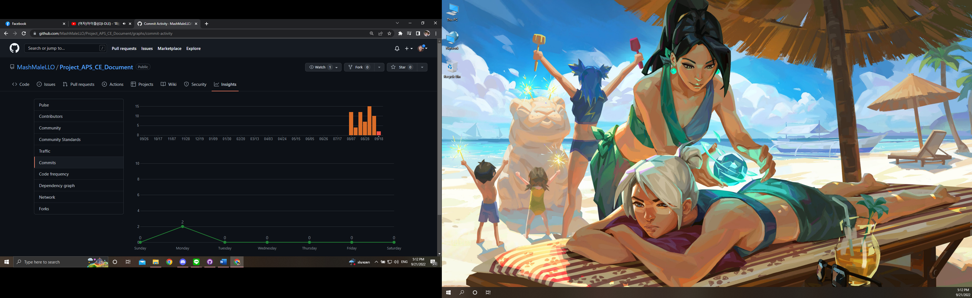

### Contributors

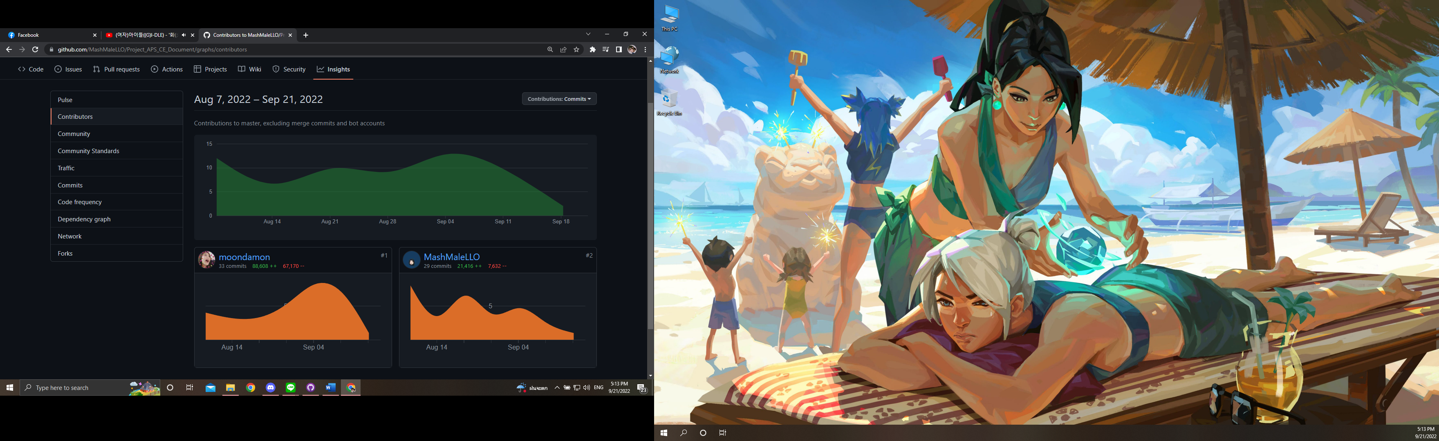

### Commit Messages

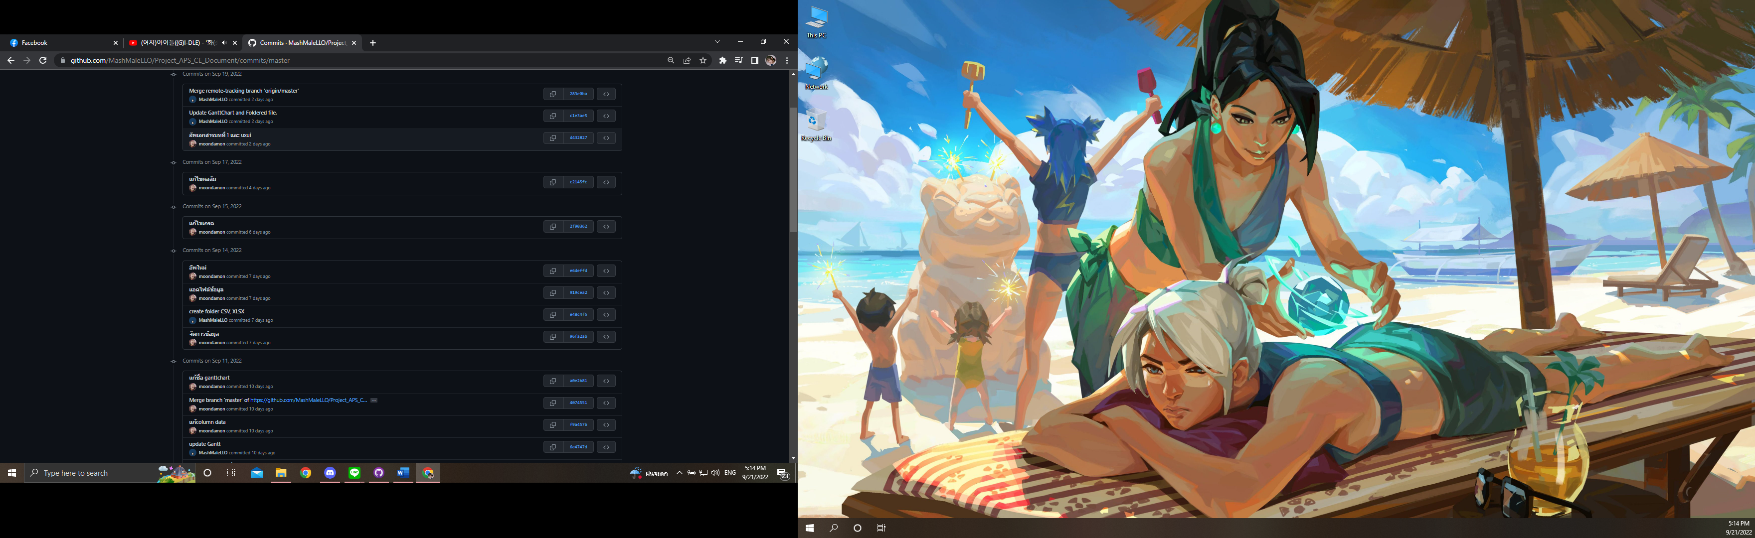

## Repo 2 Project_APS_CE_DEV

### Commits

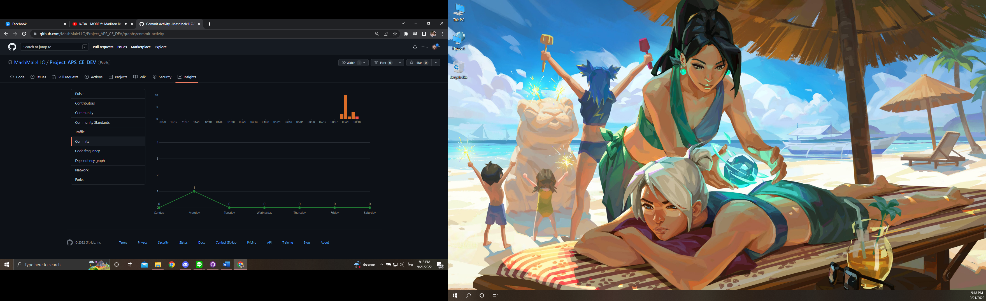

### Contributors

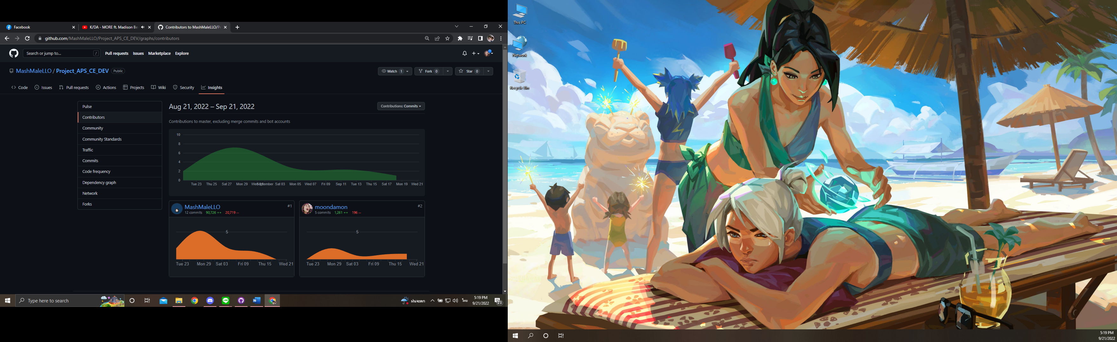

### Commit Messages

